**Write a function which accepts the reg_no and print the total marks. The student table has the fields: reg_no, name, physics_mark, chemistry_mark and maths_mark.**

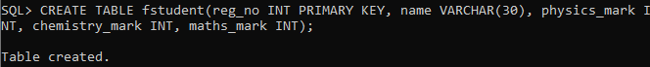

**Function:**

CREATE OR REPLACE FUNCTION tmark(rno NUMBER)

RETURN NUMBER AS

t number;

i fstudent%rowtype;

BEGIN

SELECT physics_mark, chemistry_mark, maths_mark INTO i.physics_mark, i.chemistry_mark, i.maths_mark FROM fstudent WHERE reg_no=rno;

t:=i.physics_mark+i.chemistry_mark+i.maths_mark;

return t;

END;

**Function call:**

DECLARE

rollno number;

t number;

BEGIN

rollno:=&rollno;

t:=tmark(rollno);

dbms_output.put_line('Total mark is: '||t);

END;

**Output:**

